**VISVESVARAYA TECHNOLOGICAL UNIVERSITY JNANA SANGAMA, BELAGAVI- 590 018**

*“AICTE Activity Point Programme”*

***Submitted in Partial Fulfilment for the Award of Degree of Bachelor of Engineering***

***in***

ARTIFICIAL INTELLIGENCE AND MACHINE LEARNING

Submitted by

**SURABHI T G - 1KS21AI051**

**Under the guidance of Prof. USHA SRI GUNTI**

**Assistant Professor**

**Dept. of AI&ML AICTE Activity Faculty In-charge**

**Prof. NAVEEN V**

**NSS Officer/AICTE Co-Ordinator of the college**



**K. S. INSTITUTE OF TECHNOLOGY**

**Department of Artificial Intelligence and Machine Learning**

**#**14, Raghuvanahalli, Kanakapura Road, Bengaluru - 560109

# K.S. INSTITUTE OF TECHNOLOGY

**#14, Raghuvanahalli, Kanakapura Road, Bengaluru – 560109**



***AICTE Activity Point Programme CERTIFICATE***

This is to certify that the **AICTE Activity Points Programme** has been successfully carried out by **SURABHI T G** bearing **USN: 1KS21AI051,** bonafide student of

**K.S. Institute of Technology** in partial fulfilment of the requirements for the award of degree of Artificial Intelligence and Machine Learning of **Visvesvaraya Technological University, Belagavi** during the years **2021-2025**. It is certified that all corrections/suggestions indicated for Internal Assessment have been incorporated in the report. The AICTE Activity Point Programme report has been approved as it satisfies the academic requirements in respect of AICTE Activity Point Programme for the said degree.

|  |  |  |  |
| --- | --- | --- | --- |
| **-----------------------------**  **Prof. Usha Sri Gunti Faculty in charge Dept. of AI&ML** | **---------------------------------**  **Dr. Suresh M B, HOD, Dept. of AI&ML, KSIT** | **--------------------------**  **Prof. Naveen V, AICTE activity coordinator,**  **KSIT** | **-------------------------**  **Dr. Dilip Kumar K, Principal, KSIT** |

**CERTIFICATE PHOTOCOPY**

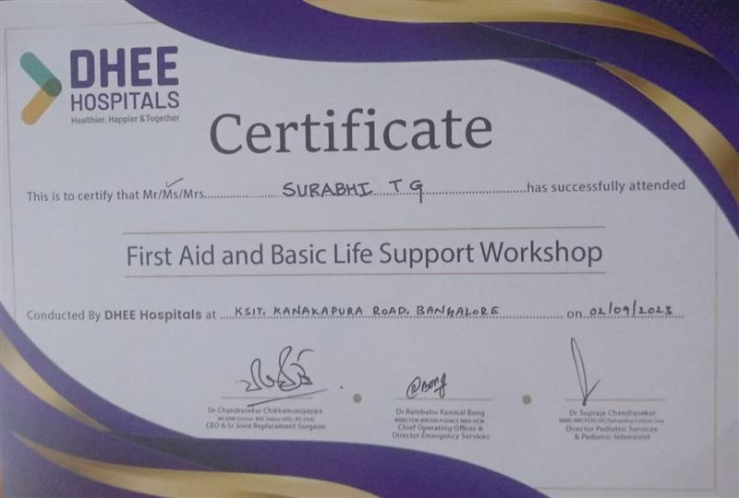

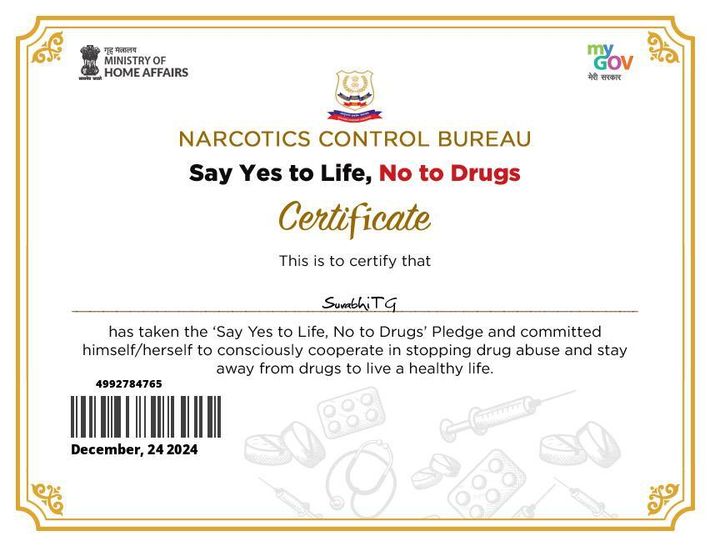

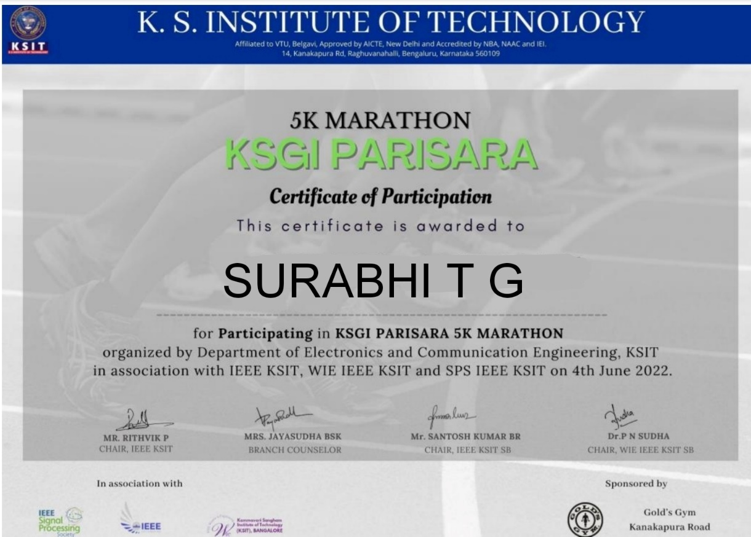

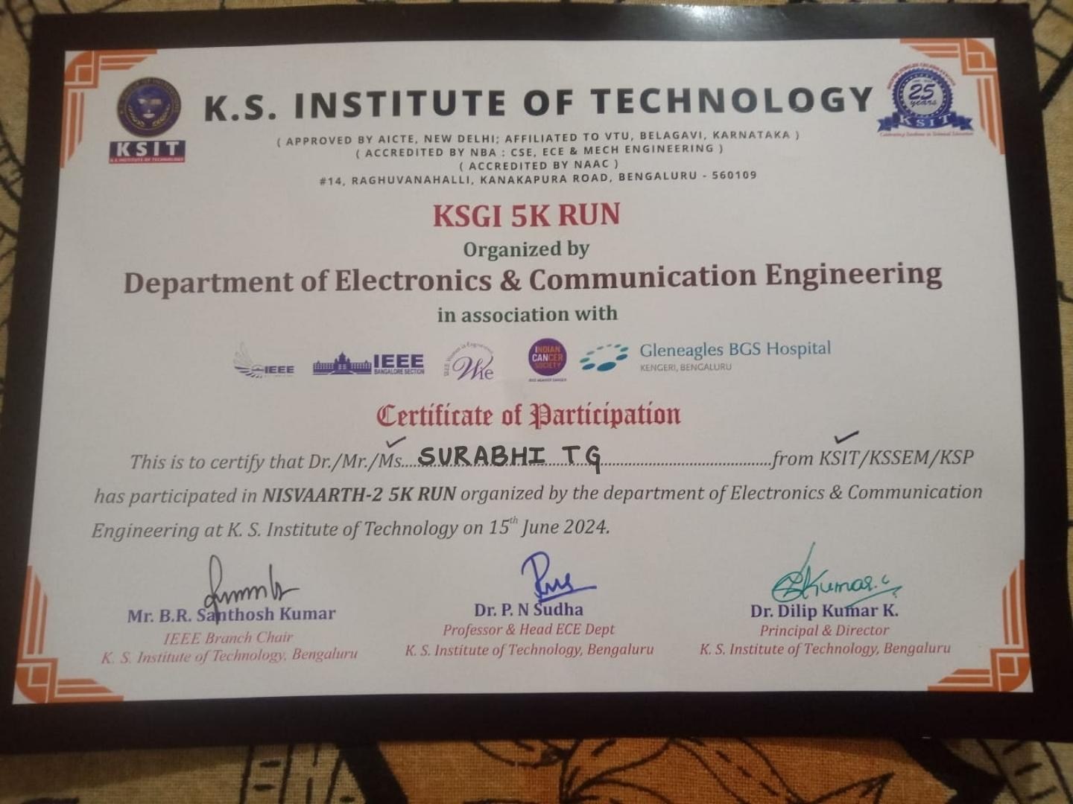

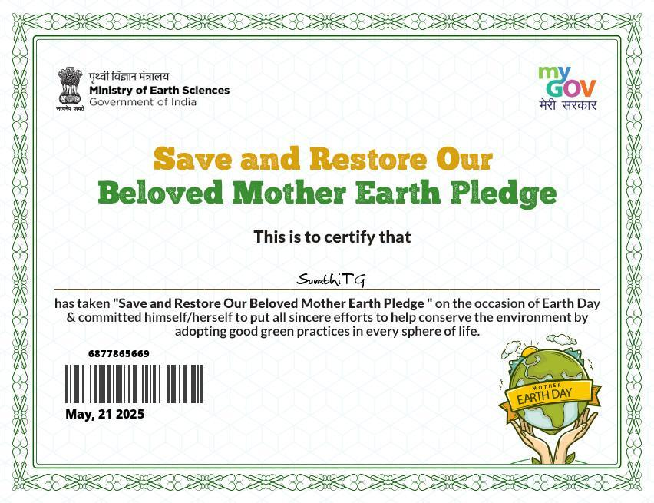

# K. S. INSTITUTE OF TECHNOLOGY

**#14, Raghuvanahalli, Kanakapura Road, Bengaluru – 560109**



## DECLARATION

I, **SURABHI T G** bearing the **USN:1KS21AI051**, student of Bachelor of Engineering, Artificial Intelligence And Machine Learning**, K.S. Institute of Technology, Bengaluru,** hereby declare that the **AICTE Activity Point Programme** work has been carried out by me under the supervision and guidance of Department Staff Coordinators submitted by me as a partial fulfillment for the award of **Bachelor of Engineering** degree in **Artificial Intelligence & Machine Learning** from **Visvesvaraya Technological University, Belagavi** during the years **2021-2025**.

I hereby declared that the AICTE activity point work has been carried out at following partner organizations:

1. Sankalpa Chase Cancer Foundation and Research Centre
2. IEEE, KSIT
3. MyGov
4. Red Cross Society
5. Amazon Distributors Pvt. Ltd.
6. Cauvery Charitable Trust

**SURABHI T G**

**1KS21AI051**

## ACKNOWLEDGEMENT

I extend my heartfelt gratitude to the Management**, Dr. K.V.A Balaji,** CEO, K.S. Institute of Technology along with **Dr. Dilip Kumar K**, Principal of K.S. Institute of Technology**, Dr. Suresh M B,** Professor & Head of Artificial Intelligence & Machine Learning**, Prof. Naveen V,** AICTE Activity Coordinator at K.S. Institute of Technology and **Prof. Usha Sri Gunti,** Assistant Professor at K.S. Institute of Technology for their unwavering support and provision of essential resources for the successful execution of this program.

I am also deeply thankful to **Sankalpa Chase Cancer Foundation & Research Centre, IEEE, KSIT, MyGov, Red Cross Society, Amazon Distributors Pvt. Ltd** and **Cauvery Charitable Trust** for their invaluable support in offering meaningful volunteering opportunities and resources.

Lastly, I would like to express my sincere appreciation and respect to my parents, the teaching and non-teaching staff of the Department, and all my friends who have supported me, directly or indirectly, throughout my AICTE Activity Point Programme journey.

**SURABHI T G**

**1KS21AI051**